Week 1

Operation performed

1. **Extract:**

* We have obtained the data and imported to PowerBI using Get Data and clicking on respective format/mode.
* Clicked on Load as there are no changes to be made.

1. **Transform:**

* Click on Transform Data from Home menu. It will take you to the Power query editor.
* Create the duplicate of the Data set.
* Make the respective changes.

1. Right click on the column header and select Remove to remove that column.

* Click close and apply.

1. **Load:**

* Open the saved file to do analysis.

**Reference Figure**

1. **Home menu in PowerBI**

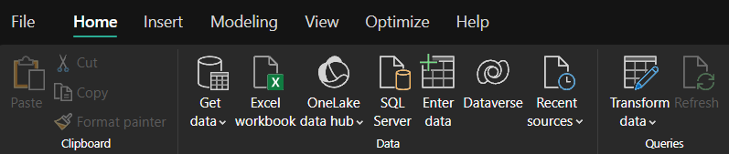

1. **Home menu in Query editor**

